

**CS 319**

**Object-Oriented Software**

**Engineering Project**

**Final Report**

**Section 2 / Group 2K**

**Ege Darçın**

**Alptuğ Albayrak**

**Özgün Özkan**

**Furkan Erdem**

**Instructor: Bora Güngören**

1) Introduction 3

2) Installation 3

3) GamePlay 4

3.1) Main Menu: 4

3.2) Player Select Menu: 5

3.3) Settings Menu: 6

3.4) Credits Menu: 7

3.5) How to Play Menu: 8

3.6) In Game Screen: 8

4) Non Implemented Specifications and Changes 11

## 1) Introduction

Headball is a 2D arcade game. The game will basically start with the main menu which includes play,settings, credits, how to play and exit sections. Before starting the game, user is going to have an option to choose his/her favorite character to play. Main object of the game is to score against the other player and to make higher score than the other player when the given time is finished. When the game starts, there will be two goals on each sides and the football players will begin the game infront of their goals. A ball will appear in the middle of the field and each player is going to try to hit the ball to score. In order to make the game more enjoyable, there will be different modes(normal and the random mode) and powerups. There will be different power ups such as fast movement and fireball which will be able to used by the player when the user triggers the related powerup via a key binded to it. The current score is always going to be displayed and updated on the provided scoreboard.

## 2) Installation

Java Runtime Environment has to be installed on the computer to run the game. By opening the project and importing jbox2d libraries the game is ready to play. On the demo, a compacted version will be ready for the usage.

## 3) GamePlay

**Menus:**

### 3.1) Main Menu:



Main menu consists of five buttons:

* **Play**: Opens the player select menu.
* **Settings**: User can change sound settings from this menu.
* **Credits**: Shows the names of the people who worked on the game.
* **How to Play**: Shows key bindings.
* **Exit**: Exits the game.

### 3.2) Player Select Menu:

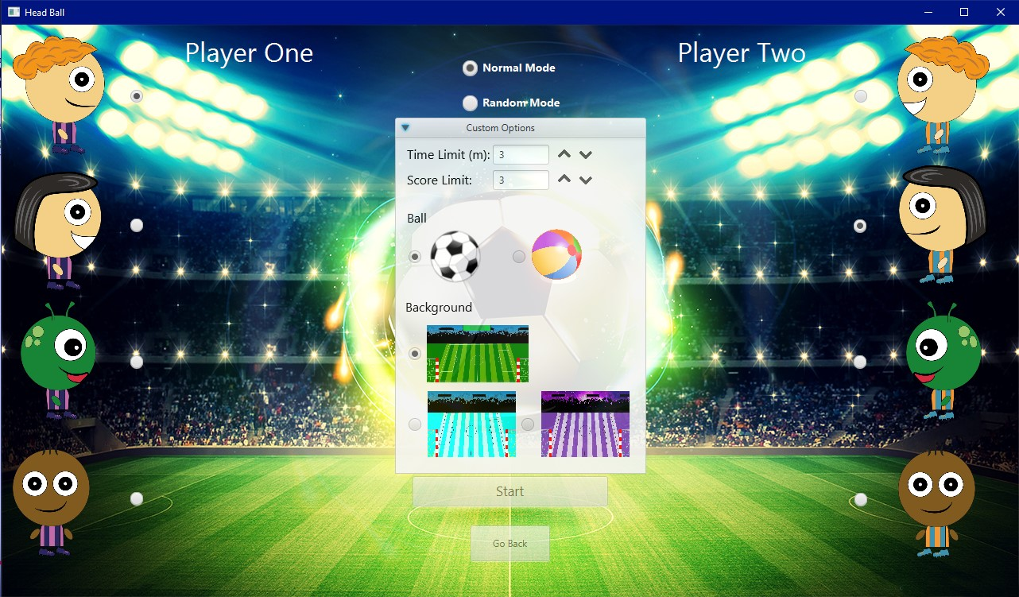

Player select menu consists of two buttons and three radio buttons group.

* **Player One Select:** First user can select his character from these 4 different avatars. Default is the first avatar. This player’s goal will be on the left side.
* **Player Two Select:** Second user can select his character from these 4 different avatars. Default is the second avatar. This player’s goal will be on the right side.
* **Game Mode Select:** Players can select different game modes from here. Default is “Normal”. The other is “Random Mode”
* A scroll bar is present for custom options. The
* **Start:** Starts the game with the selected avatars and mode.
* **Go Back:** Returns to the previous menu (main menu).

### 3.3) Settings Menu:



Settings menu consist of one checkbox and one button:

* **Sound:** User can turn on/off the sound of the game. On by default.
* **Go Back:** Returns to the previous menu (main menu).

### 3.4) Credits Menu:

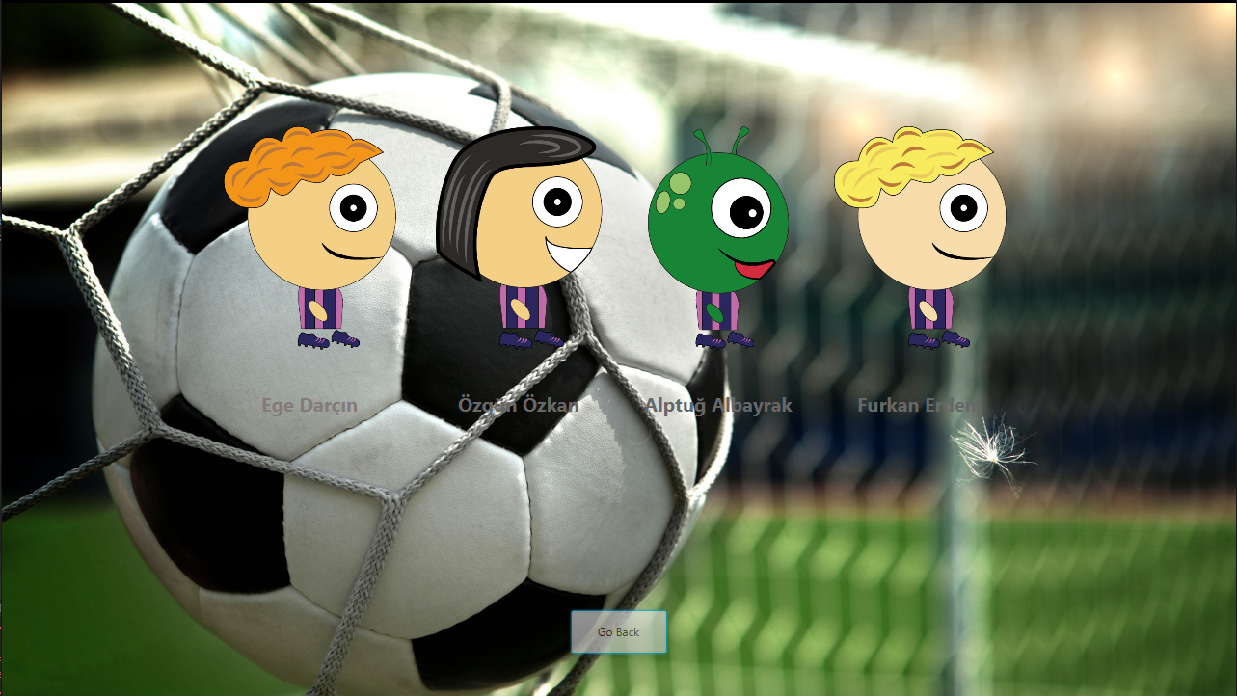

Credits menu consist of group member names and a “Go Back” button to return to the previous menu.

### 3.5) How to Play Menu:

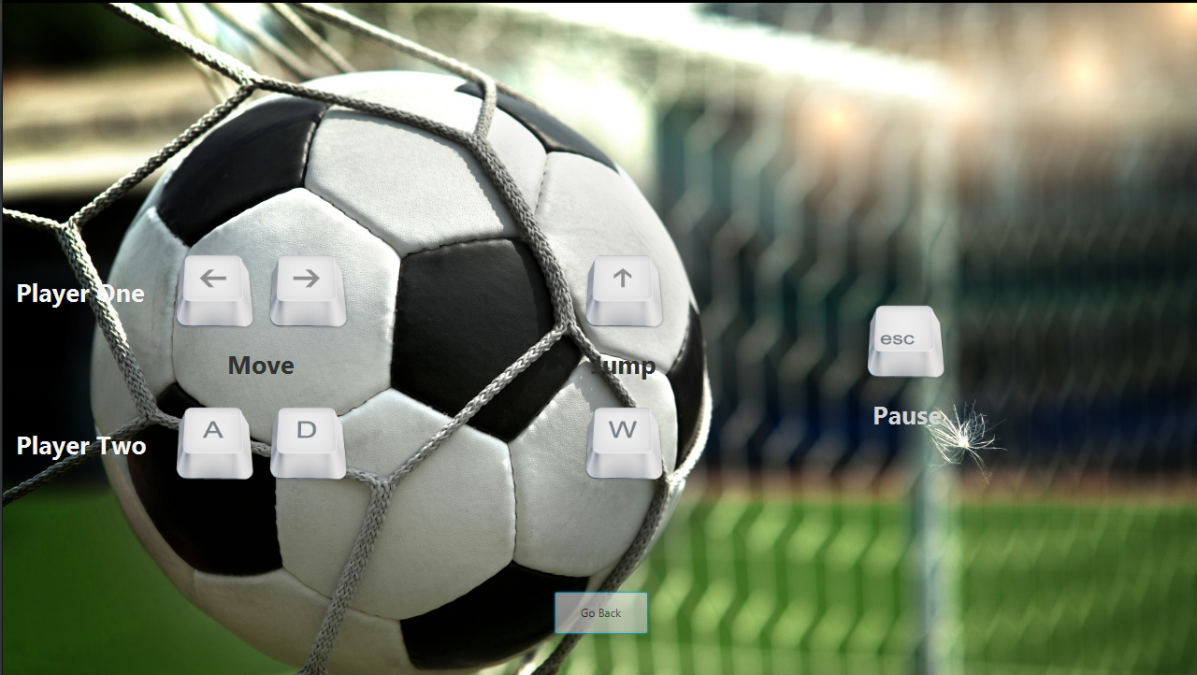

How to play menu consist of key bindings of the game and a “Go Back” button to return to the previous menu.

### 3.6) In Game Screen:

In the game, players will use their headballers to score goals. With arrow keys and w,a, s and d, players command their headballers to score goals.

There are two different balls and three different scenes. The foootball ball is a normal ball with normal physics and the beach ball is the wacky ball, where it has different physics such as higher damping and unpredictable stops when it touches the ground.

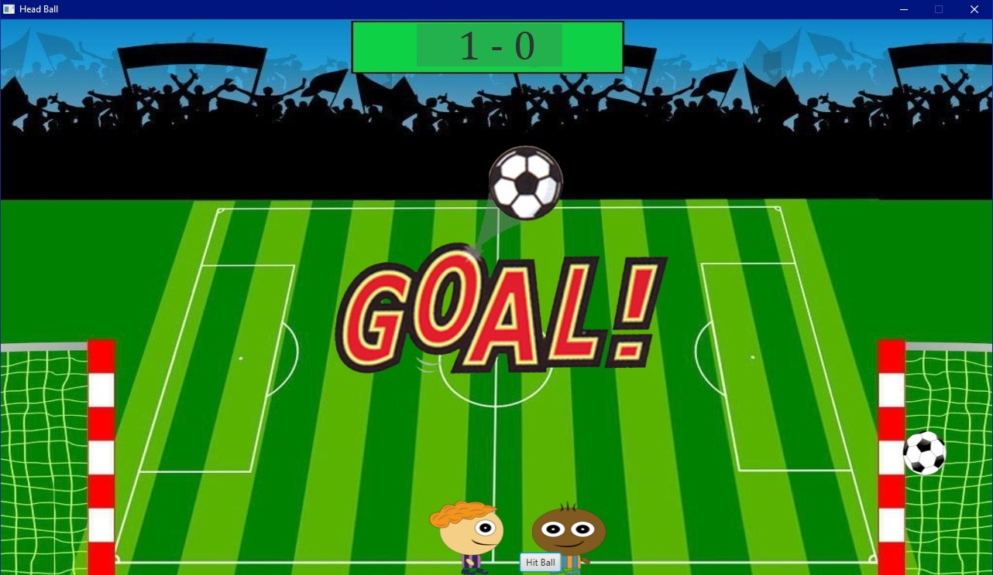

The first scene is the normal scene, where physics are normal and players combat in a normal manner.

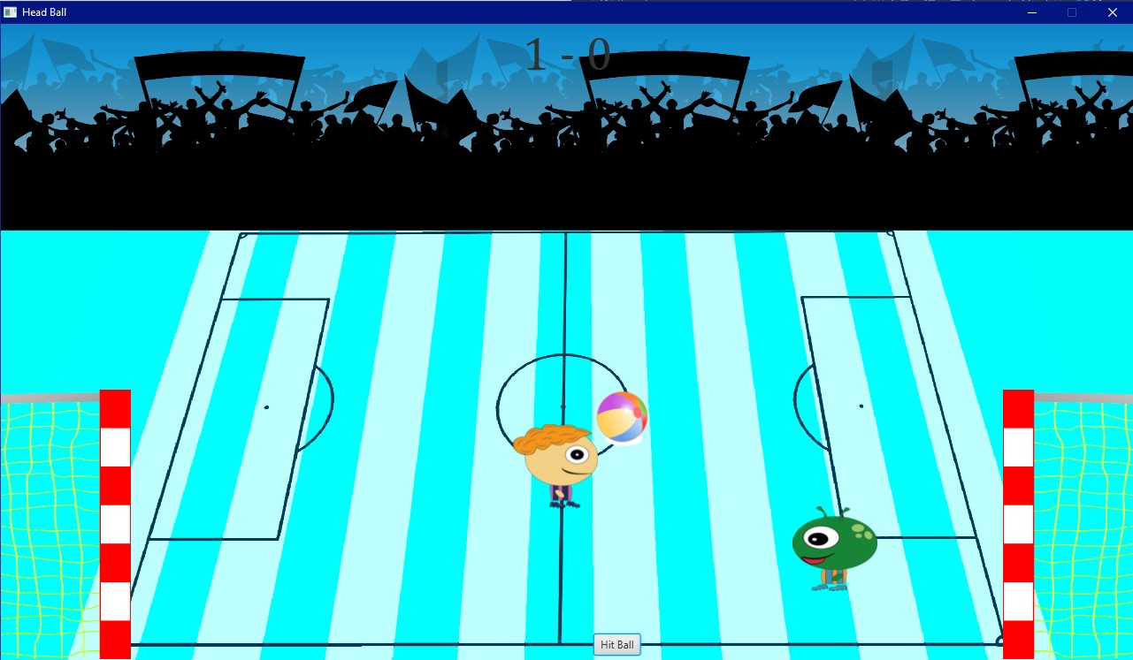

The second scene is the ice scene, where there is little to no friction. It is harder to control the ball and players.

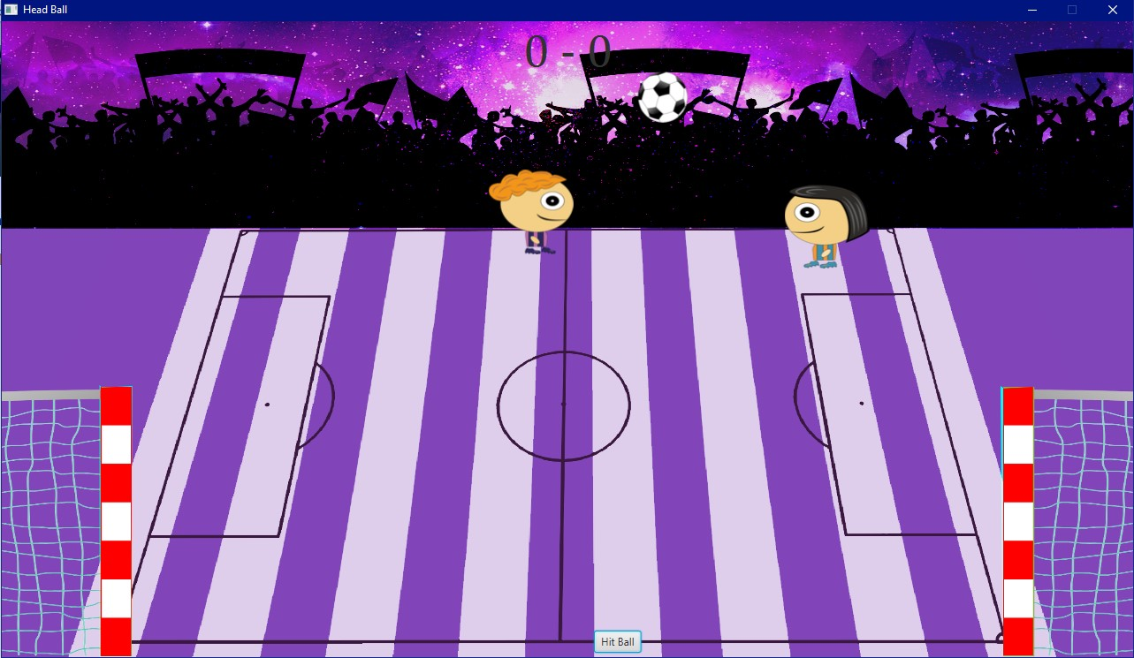

The third scene is the space scene where there is no gravity, this configuration makes the ball and headballers to move wherever they want and by using the borders they move faster, like the astronauts grabbing walls to navigate in the spaceship.

If players press escape or click the icon on the top left of the screen, options menu will pop up and bring out the pause menu.

The game ends in three ways: draw, p1 win and p2 win. If the score limit is reached, the player who reached wins. If the time runs out, the player who scored most goal wins. If the goal numbers are equal, it is a draw.

## 4) Non Implemented Specifications and Changes

Changes: Sound added in the game, for each round the cheering goes on.

Collision Listener class is added in order to detect and control the collisions between bodies.

Here is the updated class diagram:

